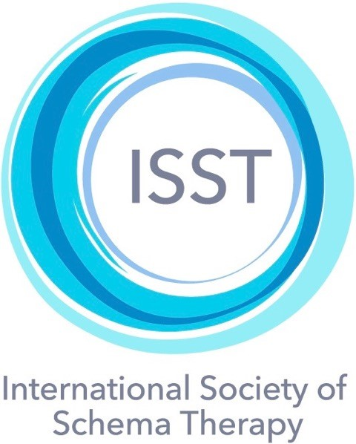
Schema Therapy Case Conceptualization Rating Scale
STCCRS v2.2 18th September 2018
Candidate’s name | Rater’s name | Patient id | Date
Instructions to raters: Please be sure to rate all 9 items using the rating scale below (do not use decimals). If the candidate omitted a section, rate it as 0. Then compute whether the candidate meets criteria for certification on Page 3.
Rating scale
 | 0 | 1 |  | 2 | 3 |  | 4 | 5 | 6
 | Poor |  | Barely  adequate |  |  |  | Good |  | Excellent

1 | Sections I – V: Basic assessment information. | Rating
The therapist has provided material for a basic understanding of the patient’s current life situation and presenting problems, (i.e., demographic data, what motivates the patient to seek therapy, general impressions, overall functioning in significant life areas, ICD-10 diagnoses, and major problems & symptoms).
2 | Section VI: Childhood and adolescent origins of the patient’s current problems. | Rating
The therapist has described the childhood and adolescent origins of patient’s current problems, (i.e., early history, unmet core needs, temperamental/biological factors, cultural, ethnic and religious factors).
3 | Section VII: Most relevant schemas | Rating
The therapist has listed the most relevant schemas; triggers; how the schemas play themselves out and their negative effects on the patient.
4 | Section VIII: Most relevant schema modes | Rating
The therapist has listed the most relevant schema modes. The therapist has also described the situations and schemas that activate each mode; how the schema modes play themselves out; and their negative effects on the patient.
Rating scale
 | 0 | 1 |  | 2 | 3 |  | 4 | 5 |  | 6
 | Poor |  | Barely  adequate |  |  |  | Good |  |  | Excellent
5 | Section IX: The therapy relationship — including collaboration, reparenting bond and therapist’s personal reactions. |  |  |  |  |  |  |  | Rating
The therapist has presented the various relevant factors to provide a sense of the quality of both the therapeutic collaboration and the reparenting bond. When relevant, the therapist’s personal triggers, schemas and modes – and the ways that they impact on the therapy relationship – have been described. The therapist has also described steps that could help improve both the therapeutic collaboration and the reparenting bond.
6 | Section X: Therapy objectives, current progress and obstacles. | Rating
The therapist has included Therapy Objectives that are operationalized in terms of the Schemas and Modes to be targeted. Current Progress and Obstacles are identified and described.

7 | Consistency of conceptualization across all sections. | Rating
To what degree are all sections of the case conceptualization form consistent with each other, (i.e., basic assessment, early origins, descriptions of schemas & modes, the therapy relationship, and therapy objectives).

8 | Degree to which the Case Conceptualization presented in the form is reflected in the recorded session. | Rating
To what degree does the information provided by the therapist in the Case Conceptualization Form accurately capture the material in the recorded session. (Note that some information in the Case Conceptualization Form may not be reflected in the content of the recorded session).
9 | Overall rating, taking into account all aspects of the case conceptualization form. | Rating

Does the candidate meet criteria for certification?
For Standard level certification: an overall mean score of 4 or above is required for items 1-8; on items 1-9, a maximum of two ratings can be 3, and all other ratings must be 4 or above.
For Advanced level certification: an overall mean score of 4.5 or above is required for items 1-8; on items 1-9, all ratings must be 4 or above; no ratings may be below 4.
I Overall Mean Score  (Mean score of items 1-8) |  |  | Number of items scored | Total score |  | Mean score
 |  |  | 8
 | II Individual item ratings
 | Number of Ratings below 3  (items 1-9) | Number of ratings of 3  (items 1-9) |  |  | Number of ratings of 4 or above  (items 1-9)

III Final checklist of criteria for certification
Type or write Yes or No in the appropriate boxes to indicate if criteria are met
 | Standard |  | Advanced
Overall mean score | 4.0 or above |  | 4.5 or above
Ratings below 3 | None |  | None
Ratings of 3 | Max of 2 |  | None
Ratings of 4 or above | 7 or more |  | 9
Are All Criteria Met?
Rater’s signature: __________________________

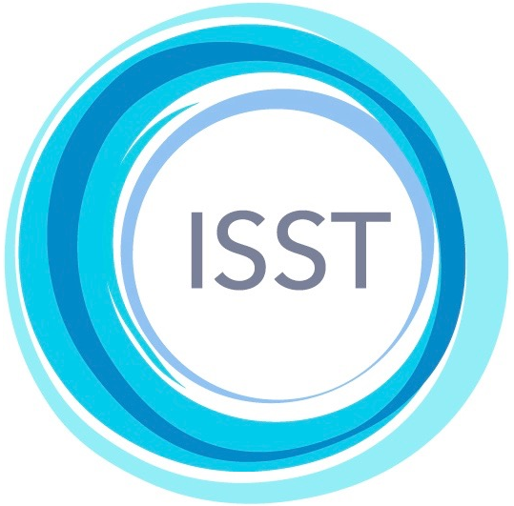
©International Society for Schema Therapy, 2018. This form may not be reproduced or translated without permission of the ISST. For more information see https://schematherapysociety.org/CCF-Translation-Committee

